|  |  |
| --- | --- |
|  |  |
| Analyzing Travel Insurance Data |  |
|  |  |
|  | 18/10/2021Low Level Design |
|  | Anshul PandeyiNeuron Intelligence Pvt Ltd |

### Document Control

Change Record:

|  |  |  |  |
| --- | --- | --- | --- |
| Version | Date | Author | Comments |
| 0.1 | 12/10/2021 | Anshul Pandey | Introduction and Architecture Defined |
| 0.2 | 16/10/2021 | Anshul Pandey | Architecture & description appended and updated. |
|  |  |  |  |

Review:

|  |  |  |  |
| --- | --- | --- | --- |
| Version | Date | Author | Comments |
| 0.1 | 18/10/2021 | Anshul Pandey | Unite Test Cases to be added. |
|  |  |  |  |

Approval Status:

|  |  |  |  |
| --- | --- | --- | --- |
| Version | Date | Approved By | Comments |
|  |  |  |  |

Contents

[Analyzing Travel Insurance Data 1](#_Toc85561814)

[Document Control 2](#_Toc85561819)

[Introduction 4](#_Toc85561820)

[Architecture 5](#_Toc85561821)

[Components of Power BI Architecture 6](#_Toc85561822)

[Working of Power BI Architecture 8](#_Toc85561823)

[Power BI Service 10](#_Toc85561824)

[Working of Power BI Service 12](#_Toc85561825)

[Deployment 13](#_Toc85561826)

### Introduction

#### What is Low-Level design document?

The goal of the LDD or Low-level design document (LLDD) is to give the internal logic design of the actual program code for the House Price Prediction dashboard. LDD describes the class diagrams with the methods and relations between classes and programs specs. It describes the modules so that the programmer can directly code the program from the document. 1.2 Scope Low-level design (LLD) is a component-level design process that follows a step-by-step refinement process. The process can be used for designing data structures, required software architecture, source code and ultimately, performance algorithms. Overall, the data organization may be defined during requirement analysis and then refined during data design work.

#### Scope

Low-level design (LLD) is a component-level design process that follows a step-by-step refinement process. The process can be used for designing data structures, required software architecture, source code and ultimately, performance algorithms. Overall, the data organization may be defined during requirement analysis and then refined during data design work.

### Architecture

#### Business Intelligence Architecture

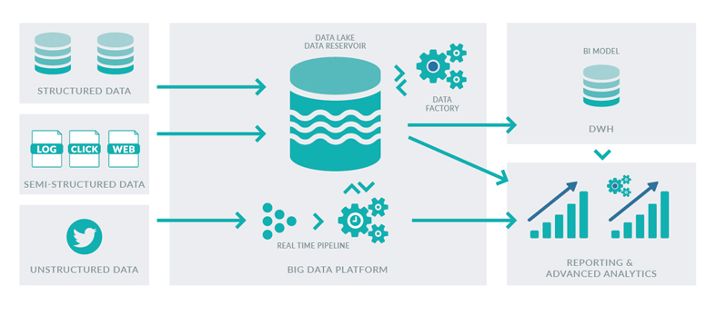

#### Power Bi Architecture

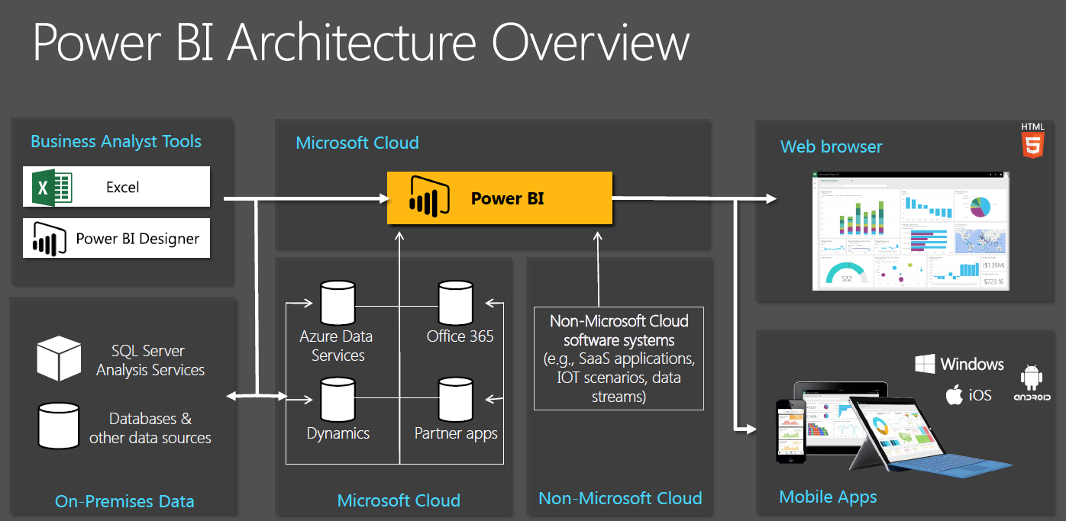

[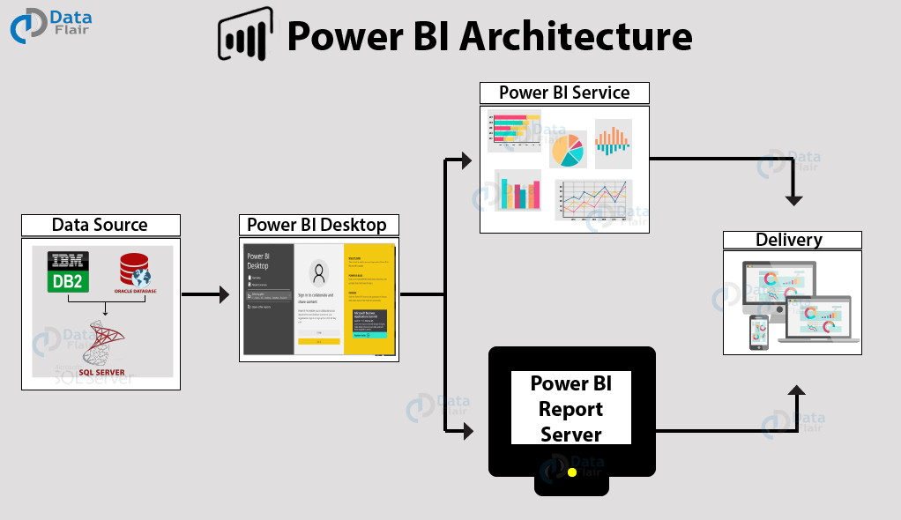](https://data-flair.training/blogs/wp-content/uploads/sites/2/2019/07/Power-BI-architecture-overview.png)

### Components of Power BI Architecture

Let us learn about the components of Power BI architecture in detail.

#### **1. Data Sources**

An important component of Power BI is its vast range of data sources. You can import data from files in your system, cloud-based online data sources or connect directly to live connections. If you import from data on-premise or online services there is a limit of 1 GB. Some commonly used data sources in Power BI are:

* Excel
* Text/CSV
* XML
* JSON
* Oracle Database
* IBM DB2 Database
* MySQL Database
* PostgreSQL Database
* Sybase Database
* Teradata Database
* SAP HANA Database
* SAP Business Warehouse server
* Amazon Redshift
* Impala
* Google BigQuery (Beta)
* Azure SQL Database
* Salesforce Reports
* Google Analytics
* Facebook
* GitHub

***You must learn about***[***Power BI Data Sources***](https://data-flair.training/blogs/data-sources-for-power-bi/)***thoroughly***

#### **2. Power BI Desktop**

Power BI Desktop is a client-side tool known as a companion development and authoring tool.

This desktop-based software is loaded with tools and functionalities to connect to data sources, transform data, data modeling and creating reports.

You can download and install Power BI Desktop in your system for free. Using Power BI Desktop features, one can do data cleansing, create business metrics and data models, define the relationship between data, define hierarchies, create visuals and publish reports.

#### **3. Power BI Service**

Power BI Service is a web-based platform from where you can share reports made on Power BI Desktop, collaborate with other users, and create dashboards.

It is available in three versions:

* Free version
* Pro version
* Premium version

Power BI Service is also known as, **“Power BI.com”**,**“Power BI Workspace”,** **“Power BI Site”** and **“Power BI Web Portal”**. This component also offers advanced features like natural language Q&A and alerts.

#### **4. Power BI Report Server**

The Power BI Report Server is similar to the Power BI Service. The only difference between these two is that Power BI Report Server is an on-premise platform. It is used by organizations who do not want to publish their reports on the cloud and are concerned about the security of their data.

Power BI Report Server enables you to create dashboards and share your reports with other users following proper security protocols. To use this service, you need to have a Power BI Premium license.

***Want to learn more about it? Check out the***[***Power BI Report Server Tutorial***](https://data-flair.training/blogs/power-bi-report-server/)

#### **5. Power BI Gateway**

This component is used to connect and access on-premise data in secured networks. Power BI Gateways are generally used in organizations where data is kept in security and watch. Gateways help to extract out such data through secure channels to Power BI platforms for analysis and reporting.

***Wait! Have you checked our Tutorial on***[***Power BI Gateway***](https://data-flair.training/blogs/power-bi-gateway/)

#### **6. Power BI Mobile**

Power BI Mobile is a native Power BI application that runs on iOS, Android, and Windows mobile devices. For viewing reports and dashboards, these applications are used.

#### **7. Power BI Embedded**

Power BI Embedded offers APIs which are used to embed visuals into custom applications.

### Working of Power BI Architecture

Now that we have understood the individual components of Power BI, let us learn how do all of these components work in tandem. We will understand the Power BI architecture with the help of this diagram.

[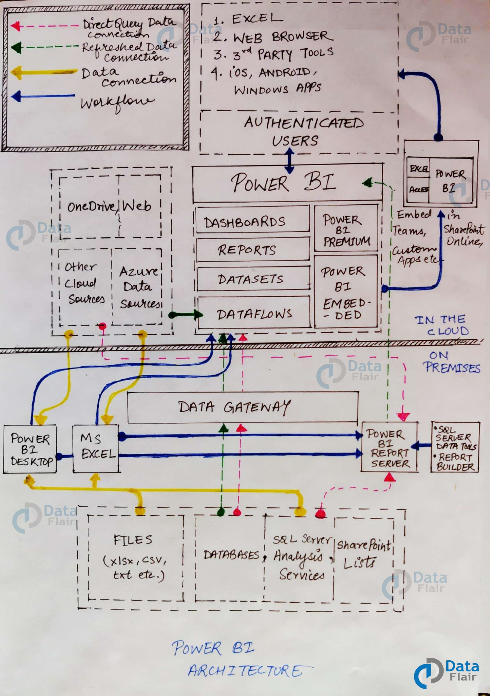](https://data-flair.training/blogs/wp-content/uploads/sites/2/2019/07/power-BI-Architecture-Diagram.jpg)

If you look closely, the diagram has numbering done on each component in the architecture. Also, note that the lower half part is the on-premise part and the upper half part depicts the on-cloud services.

To begin with, what forms the starting point or source of all the data flowing into Power BI components are the data sources. Power BI has the get data feature using which you can connect to different kinds of data sources like files, on-premise or on-cloud databases, direct connections, etc. Data connections are established from these data sources to authoring tools such as Power BI Desktop.

**On-Premise**

Power BI Desktop is a companion development, authoring, and publishing tool. You can import data from data sources to Power BI Desktop and use it to create reports and then publish them on a Power BI Service or Power BI Report Server.

You can also publish Excel workbooks directly using Power BI Publisher for Excel to the Power BI Report Server. The SQL Server Data tools and Report Publisher help in creating datasets, KPIs, mobile reports, paginated reports, etc. The reports from all kinds of reports are published to the Power BI Report Server from where they are distributed to the end-users.

**On-Cloud**

An important component in Power BI architecture is the Power BI Gateway. The Power BI Gateway acts as a secure channel to transport data from on-premise data sources to on-cloud apps or sites.

On the cloud side of the architecture, resides a lot of components. Like a complete Power BI suite having dataflows, datasets, dashboards, reports, Power BI Embedded, Power BI Premium, etc. You can embed your reports and dashboards into Teams, SharePoint, custom applications, etc. There are on-cloud data sources as well that connects to Power BI tools via direct connections.

At last, there is a layer of authenticated users who share the published reports and dashboard and collaborate with one another to make educated decisions based on the insights. There are different kinds of users who consume Power BI reports and dashboards and connect through web browsers, Excel, third-party tools, and mobile devices (iOS, Windows, Android apps).

### Power BI Service

As we have learned in the earlier sections, all the reports that you create in Power BI Desktop are published on a cloud platform known as Power BI Service.

Users can access the reports and dashboards from Power BI Service using client platforms like websites, mobile devices, etc. This means that every client who wants to access content created on Power BI needs to interact with Power BI Service. And so, we must take a look under the hood and learn how Power BI Service works.

Power BI Service’s architecture consists of two parts:

* A front end
* A back end

**Front End cluster**

The front end also called the web front-end cluster acts as an intermediary between clients and the back end. The front end services are used for establishing an initial connection and authenticating clients using Azure Active Directory. The Azure Active Directory stores user identities.

Along with this, Azure Traffic Manager is used to direct user requests to the nearest data center after authentication. Once a client/user is authenticated, the **Azure Content Delivery Network (CDN)** distributes static Power BI content/files to users.

[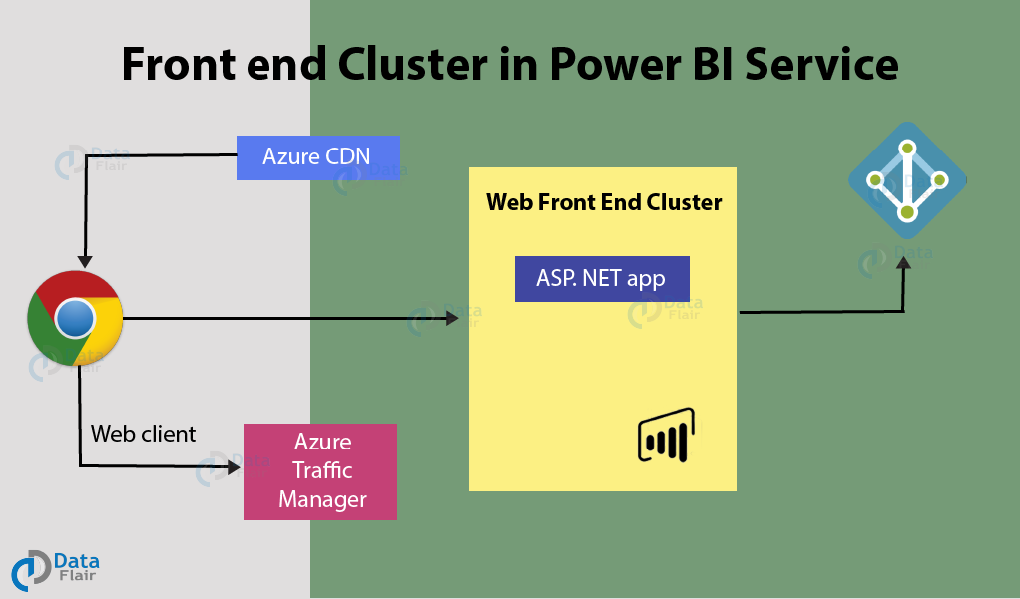](https://data-flair.training/blogs/wp-content/uploads/sites/2/2019/07/Frontend-Cluster-in-PowerBI-architecture.png)

**Back End Cluster**

The Power BI services at the back end take care of visualizations, datasets, storage, reports, data connections, data refreshing, and other interactions with Power BI. At the back-end, a web client has only two direct points of interaction, **Azure API Management**, and **Gateway Role**. These two components are responsible for load balancing, authentication, authorization, routing, etc.

[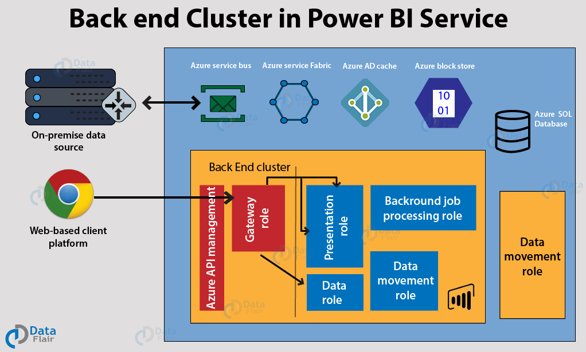](https://data-flair.training/blogs/wp-content/uploads/sites/2/2019/07/Backend-Cluster-in-PowerBI-architecture.png)

### Working of Power BI Service

* Power BI stores its data in two main repositories; **Azure block storage** and **Azure SQL database**. Azure block storage stores the datasets uploaded by users and all the metadata and system-related data is stored in the Azure SQL database.
* After Azure API Management authenticates a user request, it is sent to the Gateway Role. The Gateway Role processes the requests and directs them to suitable components like Presentation Role, Background Job Processing Role, Data Role, and Data Movement Role.
* For instance, the Presentation Role handles all the visualization related queries like for dashboards and reports.
* For all the data related queries, the request is sent by the Gateway Role to the Data Role or Data Movement Role.
* Power BI Service back end uses Azure Service Bus to connect on-premise [datasources](https://en.wikipedia.org/wiki/Datasource" \t "_blank) with the cloud. Azure Service Bus receives all the requests to fetch data from the on-premise data source. Then it processes the request and executes the query on the on-premise data source to retrieve data from it to the cloud service.
* The Azure Service Fabric manages all the microservices and components associated with running Power BI.
* Azure AD Cache helps in real-time reporting using the data stored in the in-memory of the Power BI system.

### Deployment

Prioritizing data and analytics couldn’t come at a better time. No matter what size, is already collecting data and most likely analyzing just a portion of it to solve business problems, gain competitive advantages, and drive enterprise transformation. With the explosive growth of enterprise data, database technologies, and the high demand for analytical skills, today’s most effective IT organizations have shifted their focus to enabling self-service by deploying and operating Power Bi at scale, as well as organizing, orchestrating, and unifying disparate sources of data for business users and experts alike to author and consume content.

Power BI prioritizes choice in flexibility to fit, rather than dictate, your enterprise architecture. Power BI Services and Power BI Desktop leverage your existing technology investments and integrate into your IT infrastructure to provide a self-service, modern analytics platform for your users. With on-premises, cloud, and hosted options, there is a version of Power BI to match your requirements.

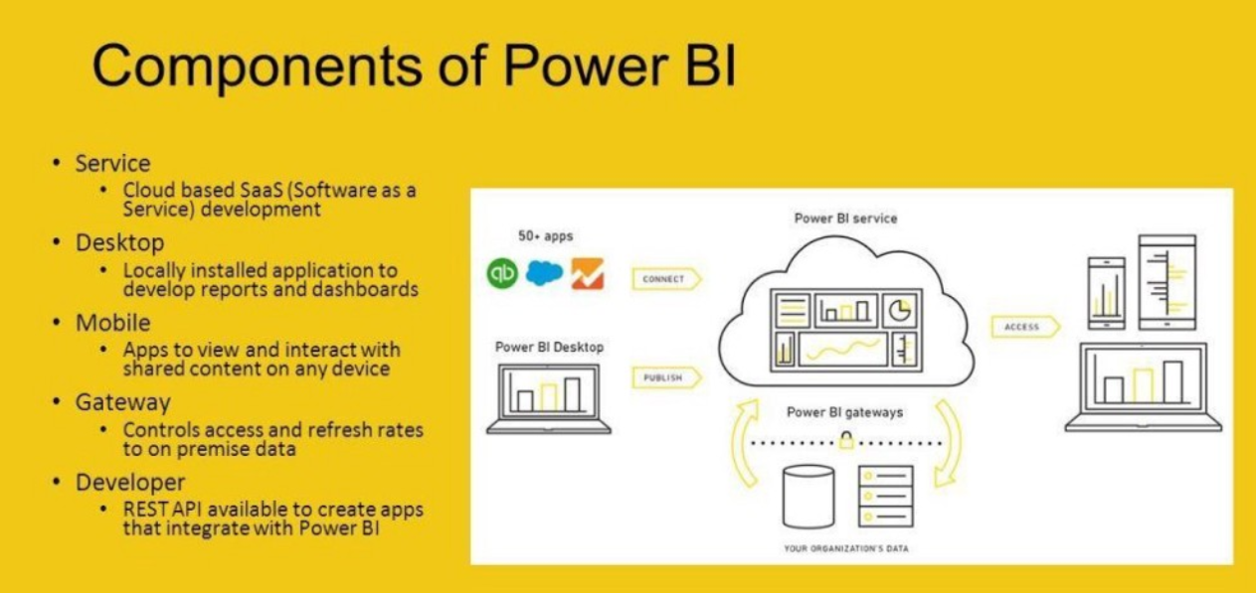

Power BI Components Comparison:

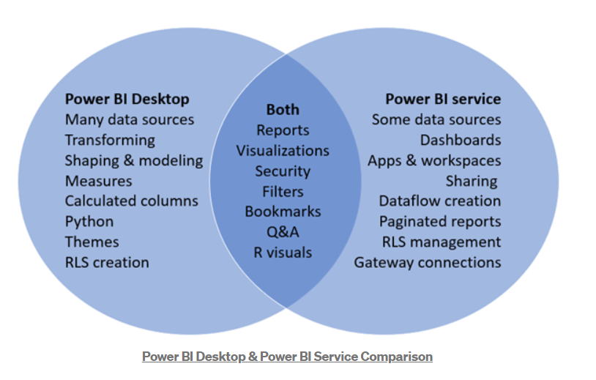

BI Desktop and Workspace should be installed by a systems administrator and the designated Power BI Services Administrator in coordination with the appropriate IT roles. For Power BI Desktop and Workspace, you will integrate with your existing technology and configure the site settings. The Data & Analytics Survey, completed by business teams, identifies and prioritizes data use cases, audience size, and users. You will use the information collected in both surveys to plan your deployment strategy, including sizing, installation, and configuration of your Power BI Desktop and Workspace or integration and configuration of Power BI Desktop and Workspace. In addition to installing Power BI Desktop and Workspace or configuring Power BI Desktop and Workspace, administrators will also need to plan for the client software installation of Power BI Desktop (Power Query), Power BI Desktop, Power BI Mobile, and Tableau Bridge Power BI Desktop and Workspace where applicable.